**IFT 166 Introduction to Internet Networking**

**Lab 19  
DHCP & DNS**

**After you complete each step, put a ‘√’ or ‘x’ in the completed box**

**Part A: DHCP Allocation through a server**

Objectives: create a simple network and allocate IP Addresses via DHCP from a server

1. 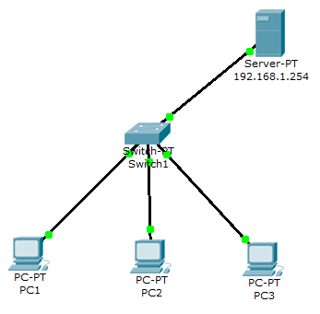Setup the following topology
2. On the server, click on DHCP option and make sure it is ‘Turned On’
3. In the start IP address boxes enter: 192.168.1.100 (this will be the starting address of the pool of IP addresses) with SM: 255.255.255.0
4. Maximum number of users: 50

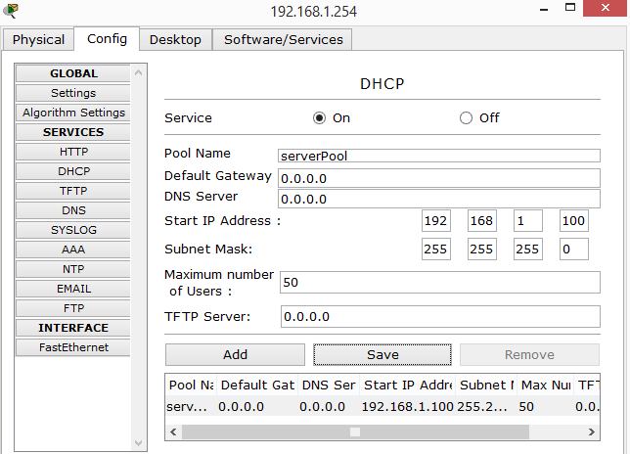

1. Click save
2. Now we to add an IP address and SM to the interface (NIC) on the server. Click the FastEthernet, option under Interface on the left panel as shown. The FastEthernet interface may be on a different tab.

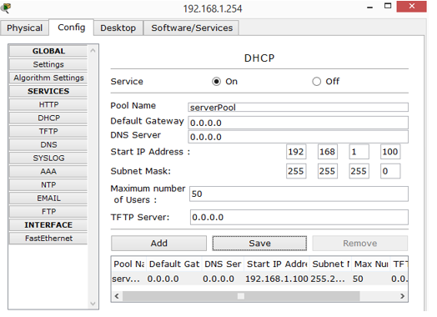



1. Enter in an IP Address and Subnet Mask (set by default once you enter the IP address). Make sure the IP address is on the same subnet as the pool of addresses you set above e.g. 192.168.1.1 would work ok.

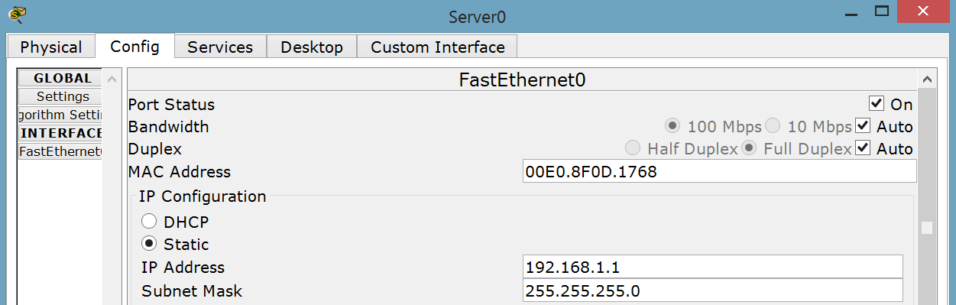



1. The server setup is now complete.
2. Now we allocate the PC IP Addresses via DHCP from the server.
3. Click PC1 and select the IP configuration option on the Desktop Tab
4. Static is ticked by default and the address settings should be blank

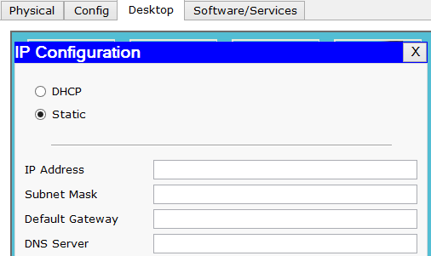



1. Click the ‘DHCP’ option and a request to the server will be made

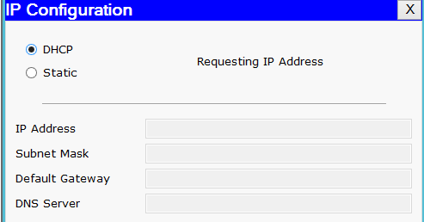



1. The computer will be allocated IP configuration details

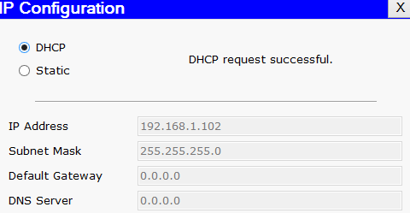

1. Now do the same procedure on the other computers and do some pinging.



**Part B: DHCP Allocation through a router**

Objectives: create a simple network and allocate IP Addresses via DHCP from a router

1. 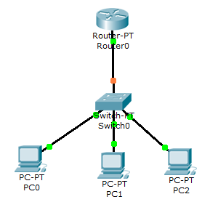Setup the following topology
2. Try and setup a DHCP connection on a PC. You should get the following as there is no router configuration.

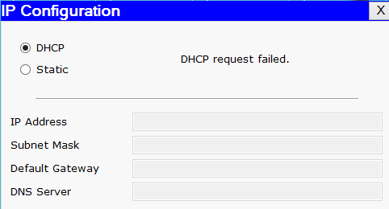



1. 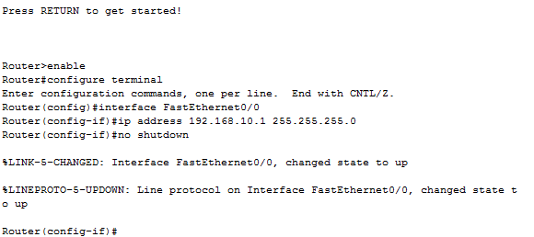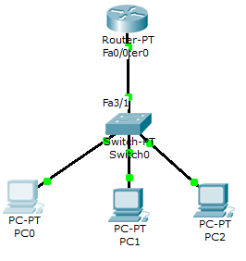We will now give the router the IP address of 192.168.10.1 with an SM of 255.255.255.0 on FastEthernet port 0/0 (Fa0/0) using the CLI on the Router. Go into the router and click on the CLI tab and type the following commands.
2. DHCP is enabled by default on a router but to shut it down, you can use the command ‘no service dhcp’, not all routers will allow you to shut it down.
3. We will now use a small bit of code to setup a DHCP pool on the router.   
   - Open the router and click on the CLI tab.

* When you open the tab you will see code has already been generated to setup the IP address and subnet mask on to the FastEthernet port 0/0.
* The port was also switched on via the ‘no shutdown’ command.
* Type exit and then hit enter to bring us back to config mode.



1. Now we will create the pool of addresses with the name IP10.

* We identify the network (the network assigned to the FastEthernet 0/0 interface) the DHCP server will be handing out IP addresses to i.e.192.168.10.0 with its subnet mask of 255.255.255.0
* We will also setup the default gateway of 192.168.10.1
* We will also exclude the first 10 addresses from the pool. These addresses (192.168.10.1) will not be handed out as they will be used things like printers, servers that have static IP addresses (ip dhcp excluded-address or ip dhcp exc for short)

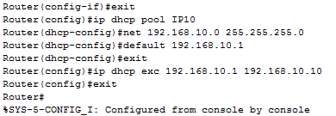



1. 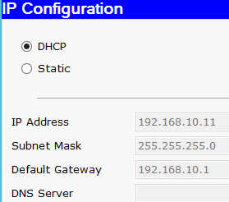Now attempt a DHCP on a client and notice the starting address.



**Part C: Setup DNS on the server**

Objectives: Setup DNS on the server to allow resolving of IP addresses

1. 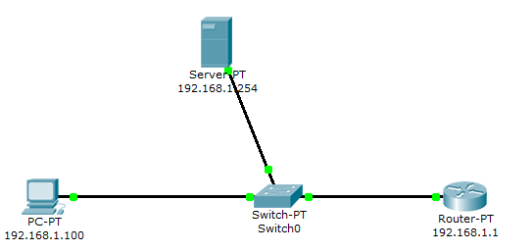Setup the following topology
2. 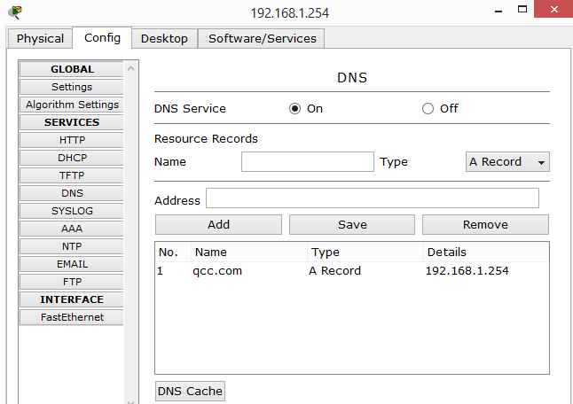Add in the gateway address onto the server and the PC
3. Open the server and turn on DNS.
4. In the name field add “qcc.com” and 192.168.1.254 in the address fields and click add
5. There is now a record resolving qcc.com to its own IP address.
6. Add in the DNS onto the PC settings.
7. On the PC, open the Web Browser and type in qcc.com and the web page should appear.